**Robotics Club Nitte**

Hands on Workshop Report

Date: 19th and 20th March, 2022

Name: Akash L M

USN: 4NM19CS012

Branch: Computer Science and Engineering

**Knowledge gained over two-day workshop**

1. **Components Used**

Home automation using Arduino UNO, 8 Channel Relay Module, HC05 Bluetooth Module, Jumper wires, Bread Board with berg pins, Cable

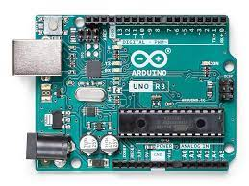**Arduino Uno:**

The Arduino UNO is the best board to get started with electronics and coding. If this is your first experience tinkering with the platform, the UNO is the most robust board you can start playing with. The UNO is the most used and documented board of the whole Arduino family.

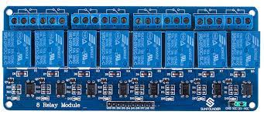 **8 Channel Relay Module:**

8 Channel Relay Board is a simple and convenient way to interface 8 relays for switching application in your project. Input voltage level support TTL as well as CMOS. Easy interface with Microcontrollers based projects and analog circuits.

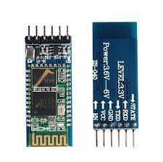**HC05 Bluetooth Module:**

HC-05 Bluetooth Module is an easy to use Bluetooth SPP (Serial Port Protocol) module, designed for transparent wireless serial connection setup. Its communication is via serial communication which makes an easy way to interface with controller or PC.

1. **Circuit Diagram**

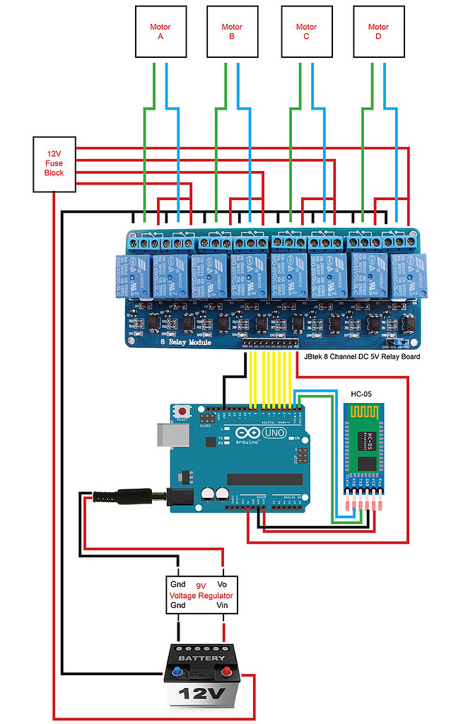

1. **Block Diagram**

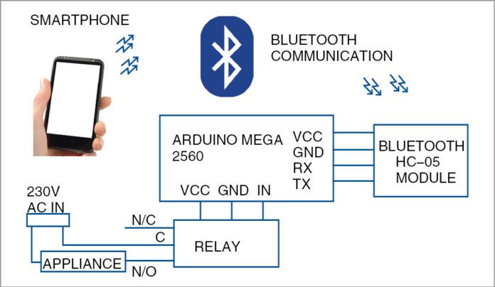

1. **Project Description**

Home automation system is use of information technologies and control system to reduce the human labor.The rapid growth of technologies influence us to use smartphones to remotely control the home appliances. An automated devices has ability to work with versatility, diligence and with lowest error rate. The idea of home automation system is a significant issue for Researchers and home appliances companies. Automation system not only helps to decrease the human labor but it also saves time and energy. Early home automation systems were used in labor saving machines but nowadays its main objective is provide facilities to elderly and handicapped people to perform their daily routine tasks and control the home appliances remotely. A Bluetooth based wireless home automation system can be implement with a low cost and it is easy to install in an existing home. A research work proved that Bluetooth system are faster than wireless and GSM systems. Bluetooth technology has ability to transmit data serially up to 3 Mbps within a physical range of 10m to 100m depending on the type of Blue tooth device. The design of proposed method is based on Arduino board, Bluetooth module, sensors and smartphone application. Bluetooth module HC-05 is interfaced with Arduino board and home appliances are connected with Arduino board via relay. Smartphone application is used for serial communication between smartphone and Bluetooth module which is further connected with Arduino board.

1. **Results**

We have introduced design and implementation of a low cost, flexible and wireless solution to the home automation. The system is secured for access from any user or intruder. The users are expected to acquire pairing password for the Arduino BT and the cell phone to access the home appliances. This adds a protection from unauthorized users. This system can be used as a test bed for any appliances that requires on-off switching applications without any internet connection.

